Power Of Two
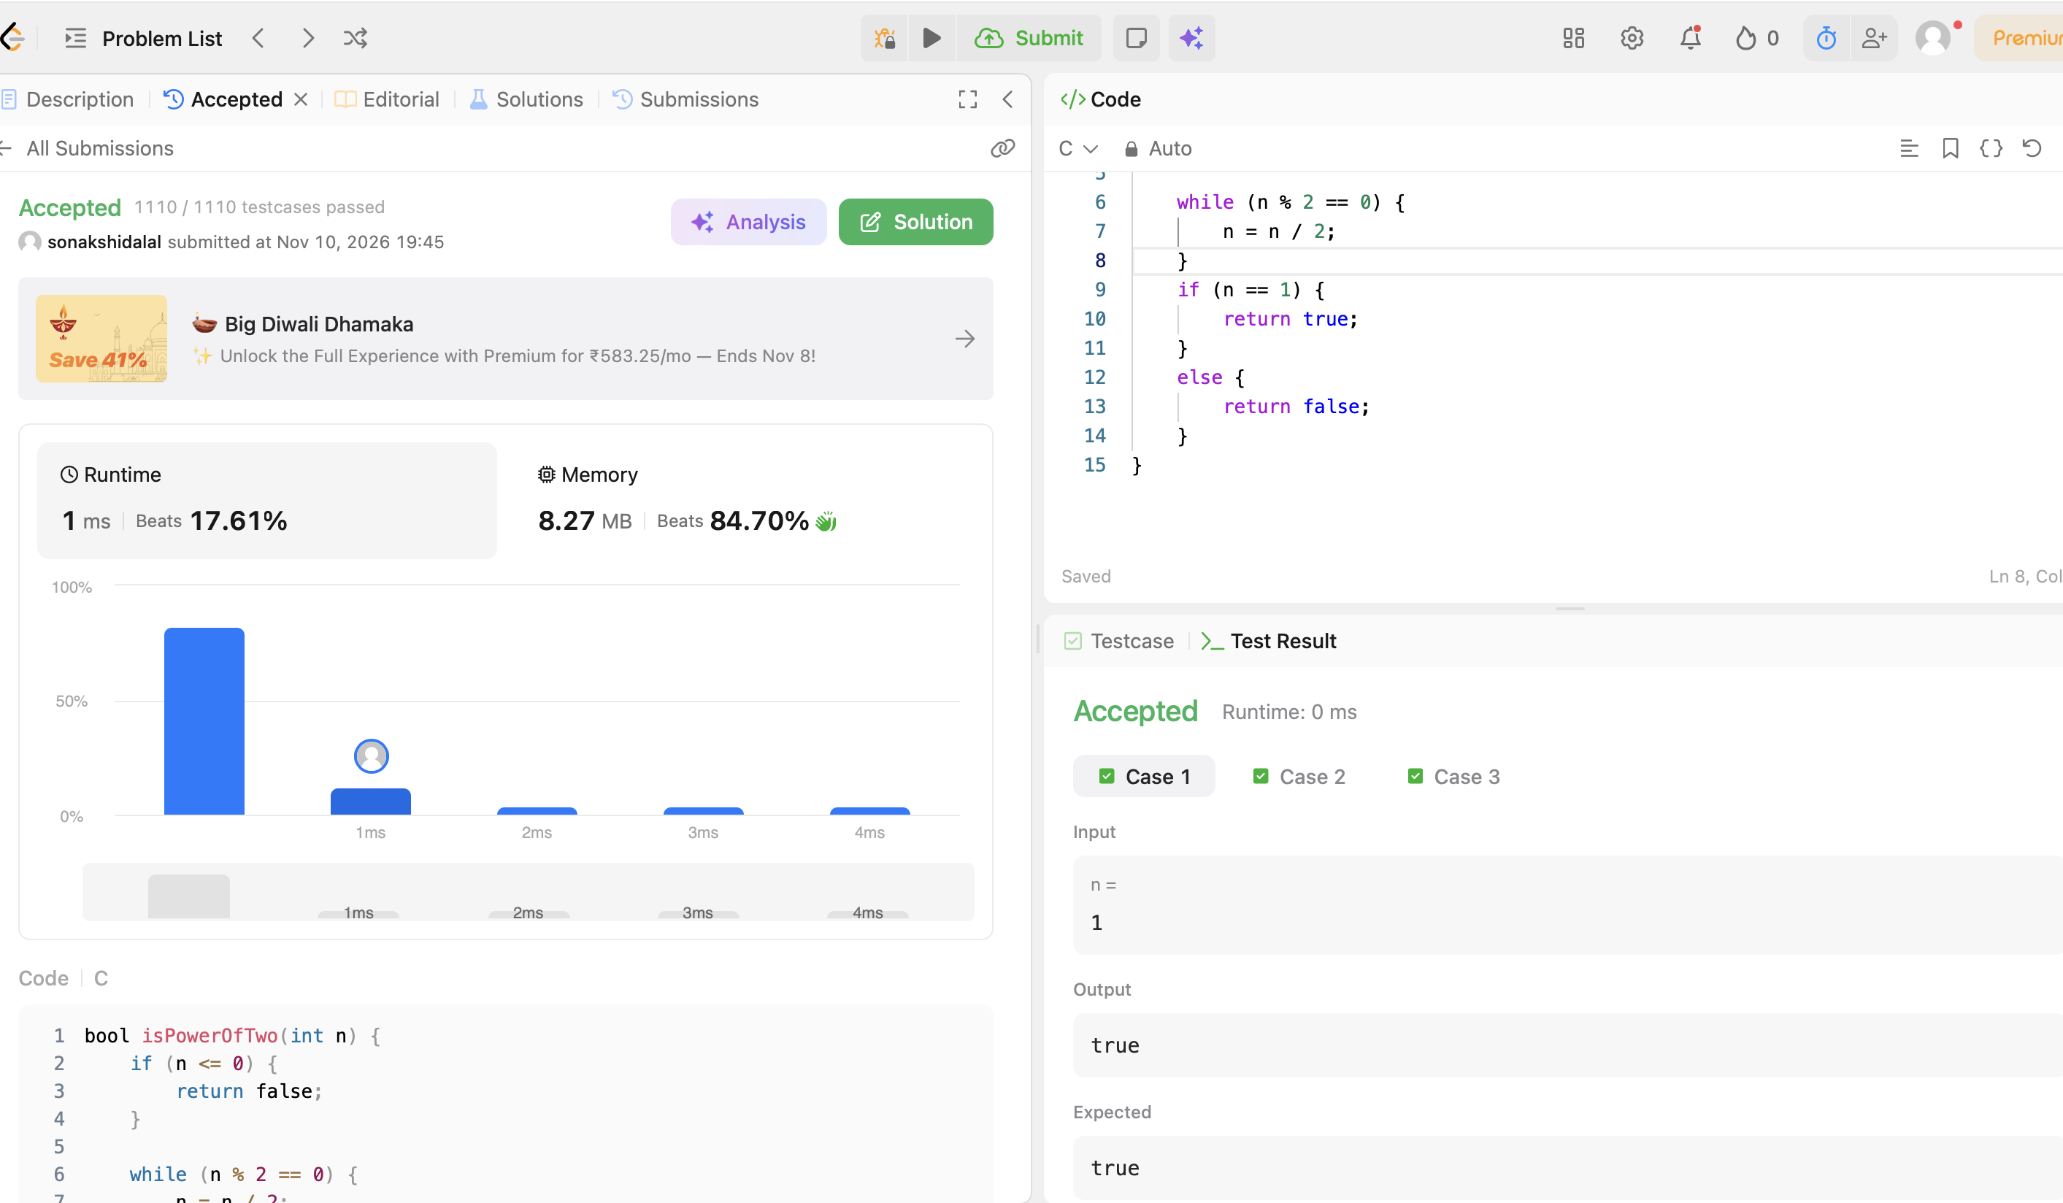
CODE:
bool isPowerOfTwo(int n) {
if (n <= 0) {
return false;
}

while (n % 2 == 0) {
n = n / 2;
}
if (n == 1) {
return true;
}
else {
return false;
}
}

